**Propeller Jet**

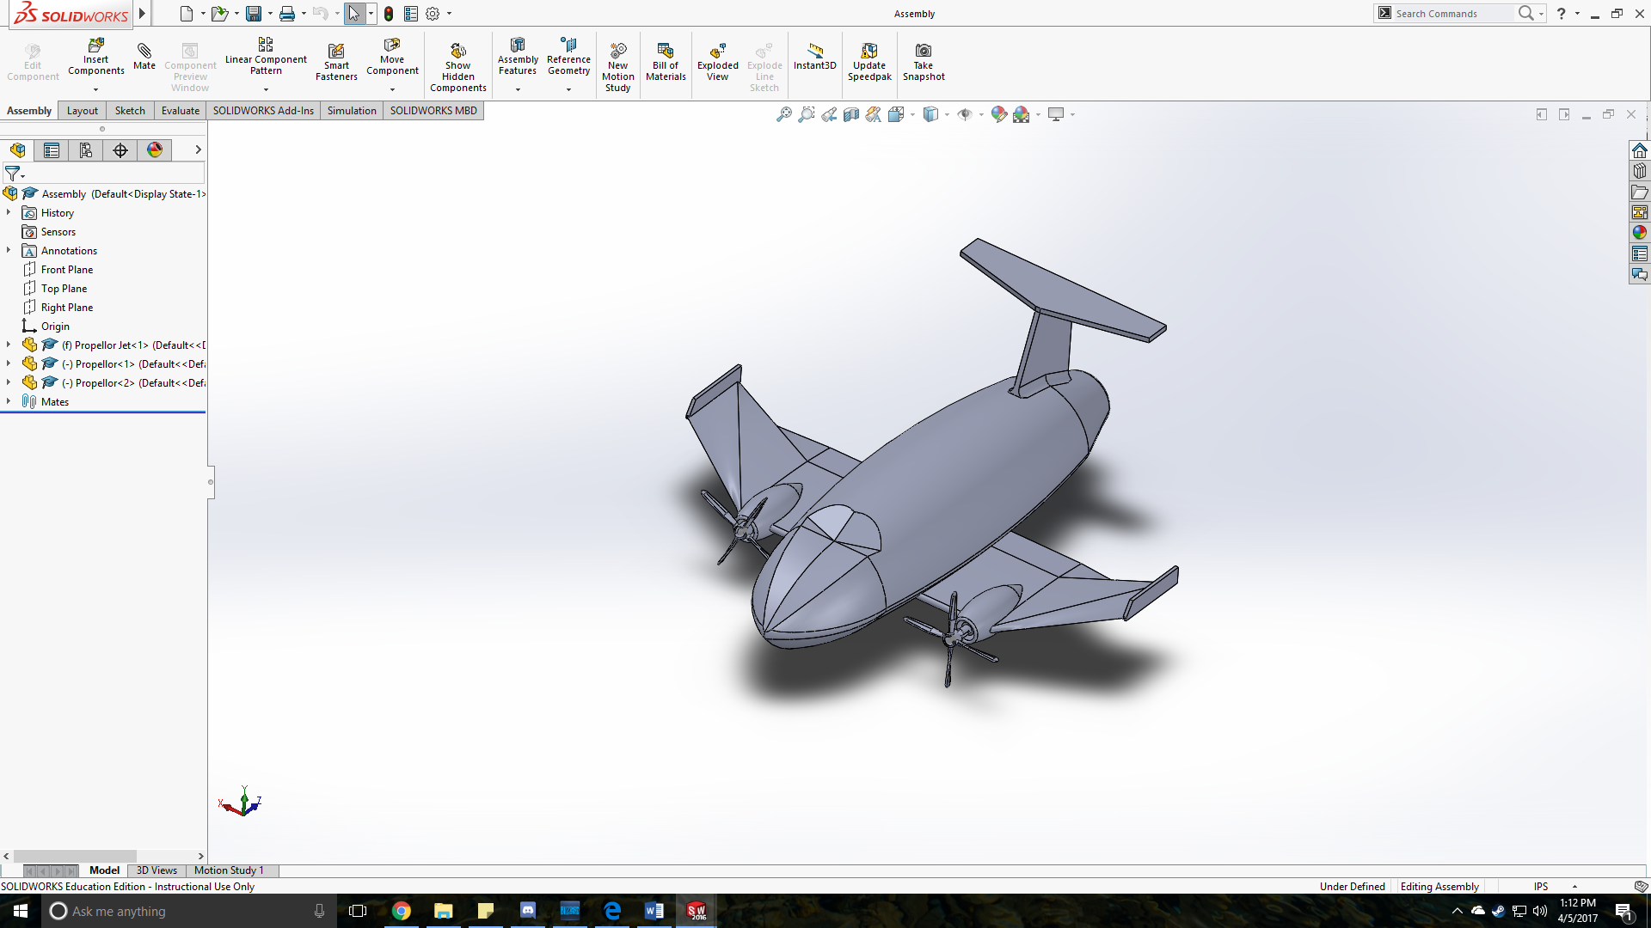

Edward Xia

Spring 2017 Section H

**Project Description:**

Ultimately, a propeller jet was decided to be printed. I knew that most likely, I would eventually design some form of vehicle with some form of rotating part attached. Deciding between a helicopter, car, bicycle, and jet, I chose the propeller jet since it seemed manageable and the interlocking features would not affect the stability of the base model. The actual sketched shape was heavily based off of the plane in figure 2. I decided to remove the wheels to reduce complexity but attempted to maintain the rotating propellers.

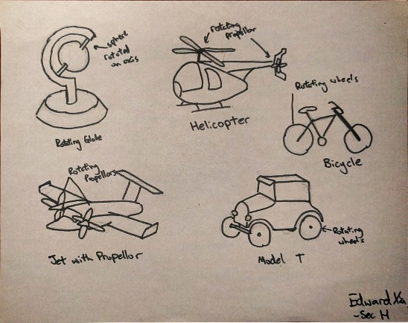

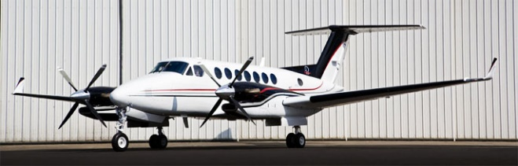

Figure 2: Actual Propeller Jet

Figure 1: Sketches of potential ideas

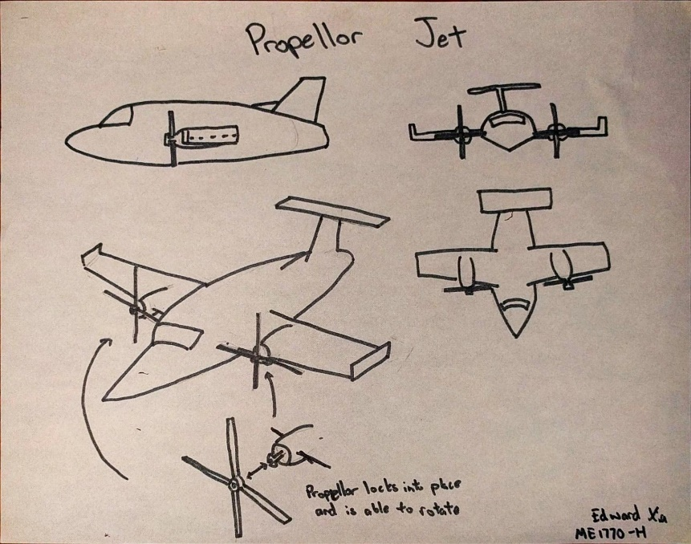

Figure 3: Design Sketch

**CAD Features:**

* Extrusion – Flat part of Wing, Wing Fin, Tail Fin, Hole in Tail(Cut), Propeller Cylinder, Hole in center of Propeller(Cut), Lower Propeller Wing
* Loft – Bottom Fuselage, Upper and Lower Nose, Dihedral part of Wing, Lower Propeller Wing, Tip of Propeller Wing
* Revolve – Upper Fuselage, Engine, Hollowed Engine(Cut)
* Sweep – Cockpit(Cut), Engine Rim, Upper Propeller Wing
* Mirror – Used to produce the other half of plane, Used in the connecting feature twice, Used to replicate into 4 propeller wing(Circular)
* Fillets – Division between upper and lower fuselage, Around Hole in Tail, Tail Fin to Fuselage

**Interlocking Features:**

* 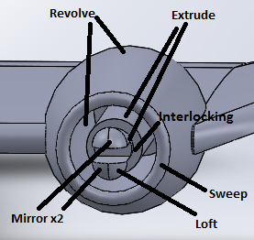The engine on both sides has a slip-fit part that allows the propeller hole to be put through the part

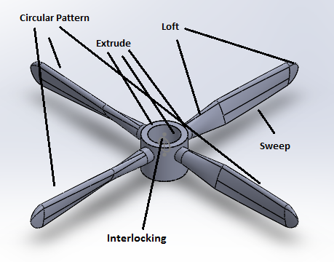

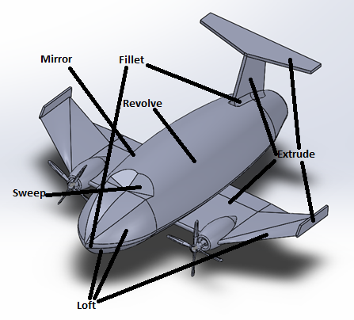Figure 4: Propeller CAD Features Figure 5: Engine CAD Features

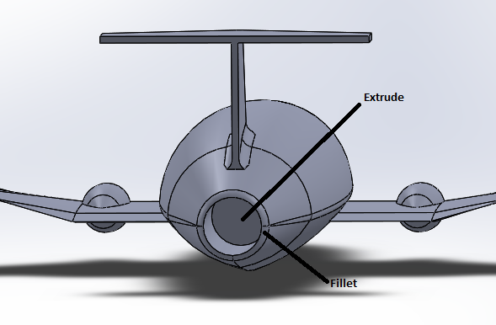

Figure 6: Plane CAD Features Figure 7: Plane CAD Features (back view)

**Design for Manufacturing Considerations:**

As stated earlier, the design for the propeller jet was largely based of the jet in figure 2. For the CAD phase of the project, several CAD operations from the DC-6 assignment (Appendix A) were used, such as the development of the fuselage and nose as well as the curvature of the propeller. Following a lot of the DC-6 assignment, many complicated and intricate features were added, such as the fact that the wing is an extruded airfoil, but proved little significance due to the small scale of the printed part. For the components design, I decided for stability purposes that the entire plane portion including the wings would be a single component. So, the plane’s wingspan and fuselage length were three inches long. The body width was reproportioned several times during the design process to make the wingspan to fuselage ratio seem reasonable. For the interconnecting part, I decided a slip-fit would be reasonable as it maintained a degree of freedom to rotate the propeller. Using the assembly in SolidWorks, I had the slip-fit part be 0.05 inches in diameter and the hole of the propeller to be .053 inches in diameter allowing a .003-inch tolerance. Ultimately, the body of the plane printed as expected, but the propellers were not printed as intended.

**Challenges in Manufacturing:**

I had extreme difficulty in visualizing the scale of the CAD model and the size of the propeller connection proved to be too small to work as intended. The small propeller was intended to be proportional to the plane itself, but, unfortunately, the printed propeller was too small and became prone to fracture. The hole in the propeller did not cut through on one of the propellers and neither propeller was able to rotate around the connection after attempting to connect them to the plane. In a potential revision of my model, the engine could be placed farther from the fuselage with a propeller hole and engine scaled two to three times its original size. Alternatively, if the object was printed on a scale three times its size, the connection would be much more likely to work as intended. Several intricate CAD operations proved insignificant on a model of a volume of 3x3x3 inches cubed. The design process could have been more efficient if these operations were not used and if the complexity of the smaller pieces was reduced. In the future, personally, I should spend more thought and consideration in visualizing and manufacturing of the print rather than focusing on the visuals provided by SolidWorks.

**Tolerances:**

**Table 1: Final Design’s Dimensions**

|  |  |  |  |
| --- | --- | --- | --- |
| **Feature** | **Dimension in CAD** | **Actual Measured** | **% Difference** |
| Tail Wing Span | 1.2 inches | 1.14 inches | 5.128 |
| Tail Wing Width* | 0.03 inches | 0.039 inches | 26.087 |
| Wingspan | 2.8 inches | 2.798 inches | 0.071 |

**\*The Caliper measured rounded to 1mm which is 0.039 inches.**

For the interlocking features, the calipers could not reasonably measure the dimensions of the engine or propeller. As for the measured components, there is a discrepancy in some of the features between the CAD dimension and the actual. Although the measured components do not affect the functionality of the print, the table shows that the discrepancy could affect how a part attaches, such as the slip-fit connection between the propeller and the engine.

**Conclusion:**

The designing process began with a sketch based off a real propeller jet. Using the SoildWorks CAD software, the sketch was created into a part with the CAD features. For the interlocking feature, the propeller was intended to rotate around the engine and was attached with a slip-fit connector. To account for discrepancies in the actual printed part, there was a 0.003 tolerance between the hole in the propeller and the diameter of the slip-fit connection. The design was then refined and reproportioned so the features resembled the proportions of an actual plane. Unfortunately, due to issues in scaling, the slip-fit connection did not work between the propeller and the engine after the part was printed, but the body was dimensioned as intended. From this project, I learned the importance of understanding the differences between the what is displayed in the CAD software and the actual printed as well as recognizing the scale of the part itself.

**Appendix:**

**A:** DC – 6 Assignment Drawing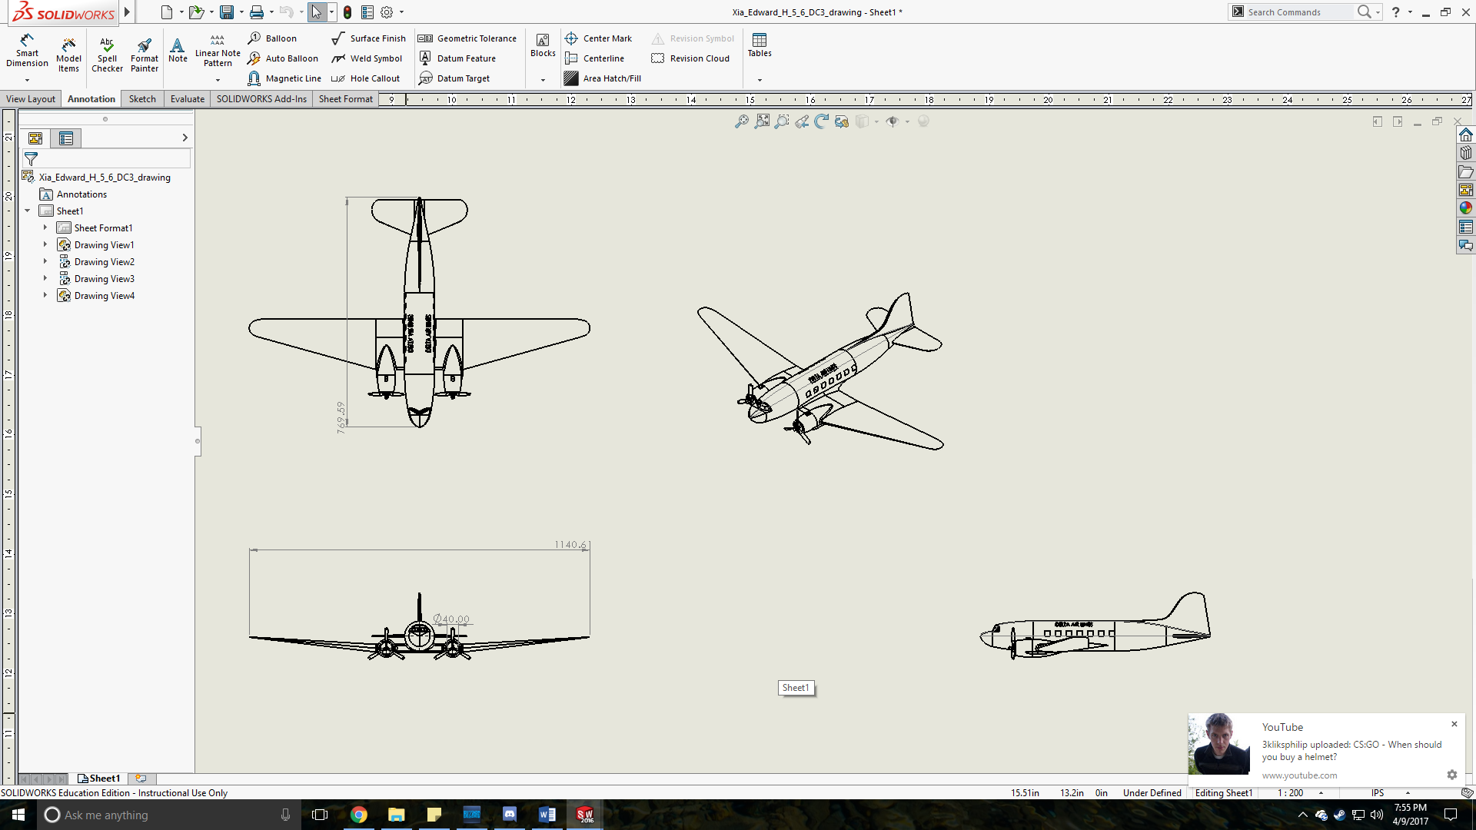

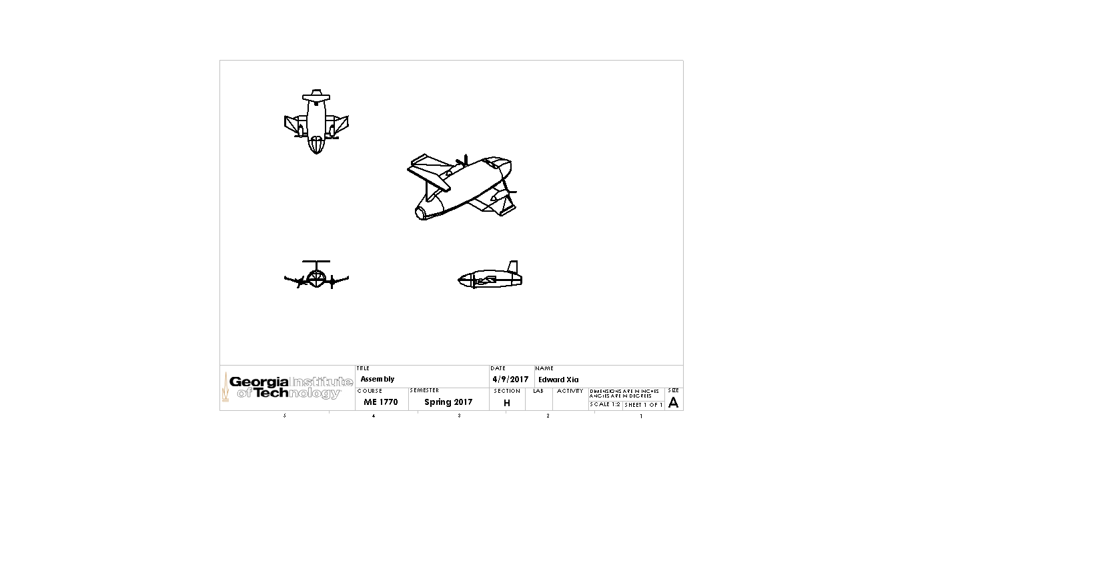**B:** Assembly Drawing

**C:** Propeller Drawing

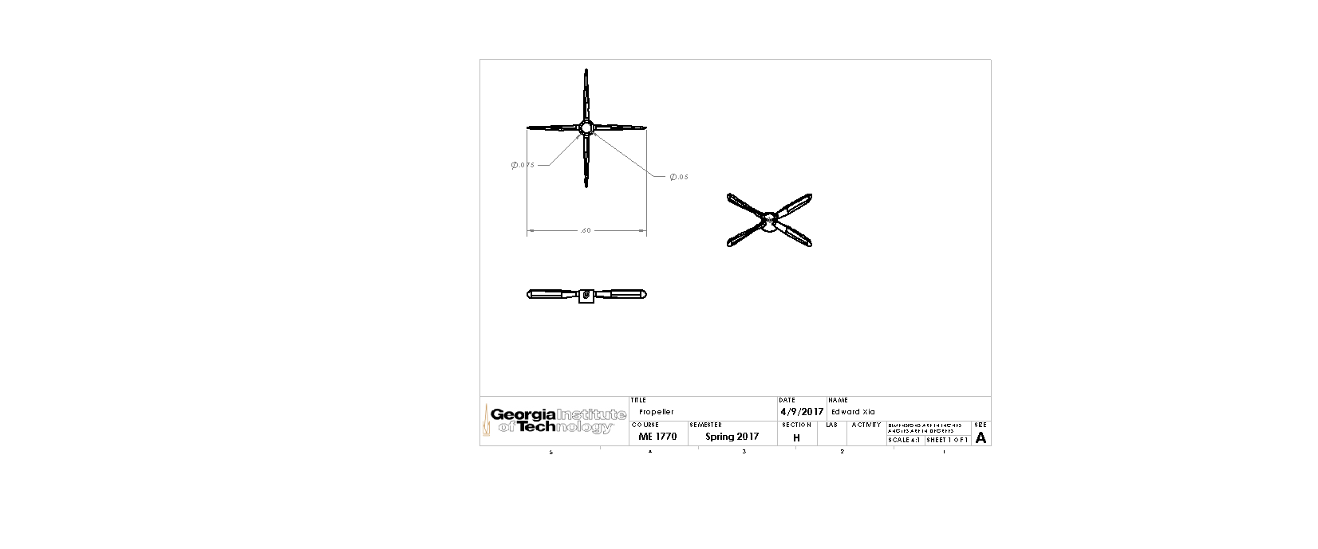

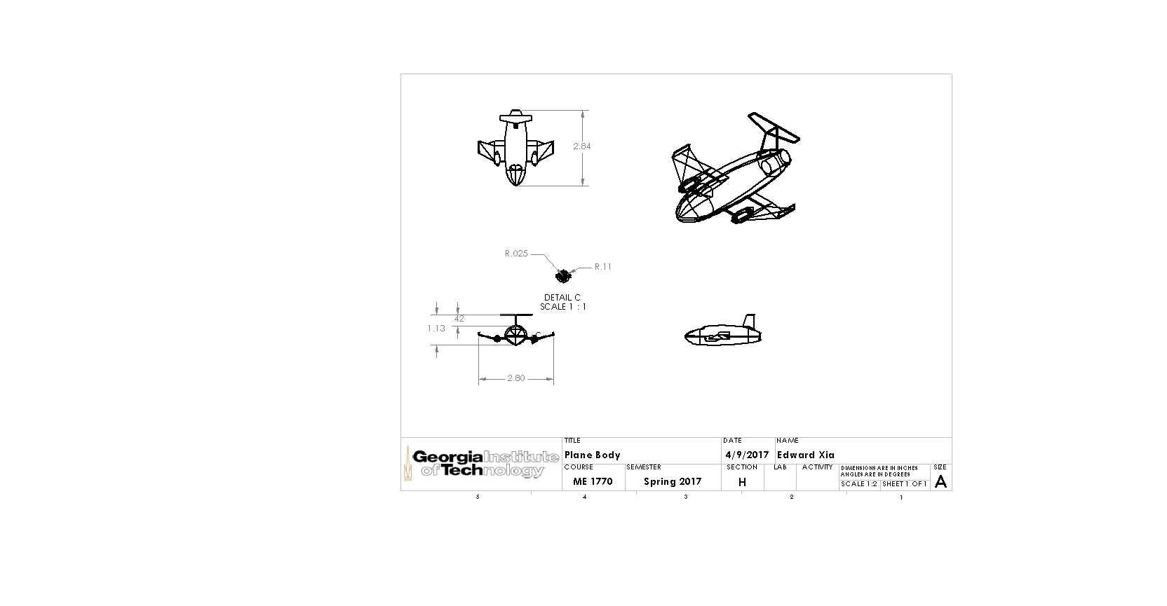**C:** Plane Body Drawing